**Project Plan for the Wave Model Component in Global Forecast Systems at NCEP (GEFSv12/GFSv16)**

**Development and Transition to Operation**

**VERSION 1.0**

**08/26/2019**

**Change History**

|  |  |  |
| --- | --- | --- |
| **Version** | **Date** | **Notes** |
| Version 1.0 | 18 Sep 2019 | Inception |
|  |  |  |
|  |  |  |
|  |  |  |
|  |  |  |

**Table of Contents**

**General Scope** **3**

GEFSv12 Wave Component (GEFS-wave) 3

GFSv16-Wave Component (GFS-wave) 3

NEMS Coupling to FV3 3

Grid redesign (completed) 4

Ocean surface-current forcing (RTOFS) 5

Physics Optimization 5

Extend forecast range: 240h to 384h (16 days) 5

Compute Resource requirements 5

**Development Tasks** **6**

WAVEWATCH III Coding 6

Internal interpolation to curvilinear grids (Roberto, completed) 6

Inclusion of winds to restart files (Jessica) 6

Model Configuration 6

NEMS Coupling 6

Workflow 6

Retrospectives 7

Post-processing 7

Modify/create scripts for archiving retrospective, real-time parallel etc 8

Verification and Validation 8

Evaluations 9

T2O 10

Timelines for tasks in progress 10

# General Scope

## GEFSv12 Wave Component (GEFS-wave)

* FV3-WW3 NEMS coupling, ESMF (First NEMS coupled system at NCEP)
* Extensive changes to GEFS workflow,
* Hike in grid resolution from ½ to ¼ degree global and two polar caps at ⅓ degree,
* Extended forecast range: 240h to 384h (16 days)
* From 21 to 31 members
* Output parameters

## GFSv16-Wave Component (GFS-wave)

### NEMS Coupling to FV3

The current operational multigrid Global Wave Model (GWM) based on WAVEWATCH III is planned to be integrated with GFS v16 for improved representation of the marine boundary layer of the atmosphere through modification of the surface roughness and low-level winds. The atmosphere-wave coupling enabled by the NEMS infrastructure will also address the objectives of simplifying the NPS by reducing the number of independent modeling systems in operations.

The FV3GFS-WW3 coupled system was developed and tested primarily for technical compatibility, and is a potential candidate for GFS v16.

The multigrid wave model will be coupled to GFS v16 with one-way interaction (no feedback from wave model to the atmosphere), allowing for simplification of NPS. All operational multigrid wave model products will be absorbed by GFS v16.

### Grid redesign (completed)

* Current grid configuration consists of a 9-grid mosaic: Global ½ deg core, ec_10, ec_4m, wc_10m, wc_4m, ep_10m, ak_10m15m, ak_4m8m, arctic 18km.
* Proposed configuration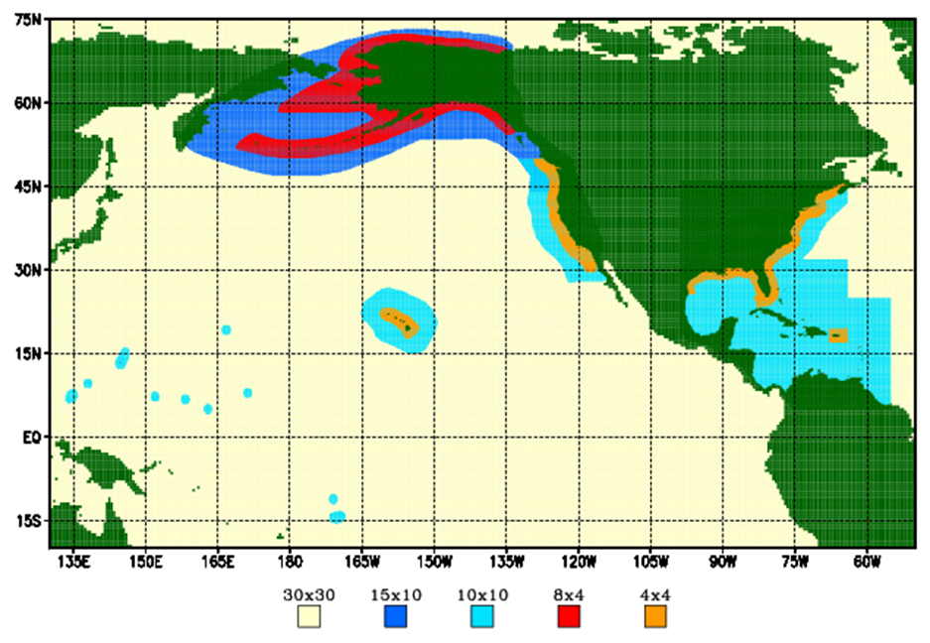
  + 3 base global grids (completed):
    - Two 9km polar stereographic caps at +- 50 to poles,
    - One regular 10 arcmin grid 55S-55N (replaces global **and** regional grids)
  + Replace 4 coastal grids (⅙ and 1/15 deg) by one 4 arcmin deg West Coast - Atlantic Grid (wcat_4m) grid.

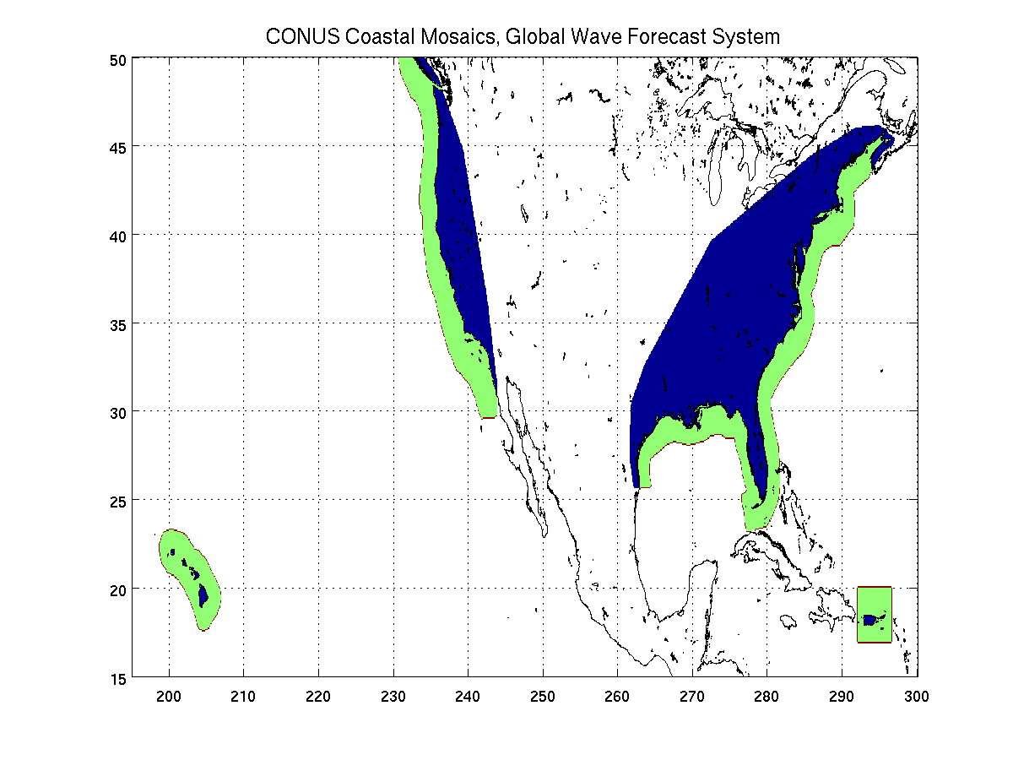

### Ocean surface-current forcing (RTOFS)

* Add scripts/codes to convert tripolar hycom netcdf data into regular 5 arcmin data file compatible with WW3 pre-processing codes
* Create 2017 archive for retrospectives
* Retrospective testing and evaluation using global base grids (NS polar stereo + regular ¼ deg core)

### Physics Optimization

* Optimization of physics consists of retuning source-term coefficients using an objective framework.

### Extend forecast range: 240h to 384h (16 days)

* Script-level changes will be added to global workflow following the new GFS 16-day extended forecast range

### Compute Resource requirements

* NODES: 50-70 nodes (currently 15 nodes)
* COM: 275-325Gb/day (currently 85Gb/day)
* PCOM: 3.5Gb/day (currently 1.1Gb/day)

# Development Tasks

## WAVEWATCH III Coding

* Addition of checkpointing capability (Henrique)

## Internal interpolation to curvilinear grids (Roberto, in progress)

## Inclusion of winds to restart files (Jessica, completed)

## Model Configuration

* Grid design (Henrique)
  + GEFS: Proposed configuration grids, input files etc (completed)
  + GFS: Proposed configuration grids, input files etc (completed)
  + GFS: Redesign if failure to run given available
* Physics tuning (Henrique)
  + GEFS: ¼ degree grid (completed)
  + GFS: global-scale grids
* Forcing by ocean surface currents (GFS only) (Henrique)
  + Development of scripts for interpolation from RTOFS tripolar grid to regular grid (completed)
  + Inclusion of currents in wave PREP, FCST and POST (completed)
  + Stand-alone retrospectives for Jan-Dec 2017 (partially completed)

## NEMS Coupling

## Workflow



* Restructuring of wave workflow to eliminate multiple PGEN and GEMPAK jobs (Henrique, in progress)
* GEFS: Integration of wave workflow to GEFS workflow for retrospective runs (Henrique, completed)
* GEFS/GFS: rehash of COMOUT directory structure for accommodating larger number of files (GEFS), and being more consistent with atmospheric model component,
* GEFS: j-jobs, fix files, parms into GEFS workflow (Henrique, completed)
* GFS: j-jobs, fix files, parm into GEFS workflow (Henrique)
* GEFS/GFS: Coding of, exwave-scripts into global-workflow (Henrique)

## Retrospectives

* GEFS retrospectives will start on Q1FY20
  + Wave model runs will be made for 1 calendar year from Dec 2018 - Dec 2019
  + Wave model runs will follow GEFS forecast ranges and cycling
    - 31 members
    - Single daily cycle 00Z
    - 16-days forecasts
* GFS retrospectives will start on Q2FY20
  + Wave model runs will be made for 1 calendar year from Dec 2018 - Dec 2019
  + There will be a real-time parallel

## Post-processing

* GEFS/GFS: renaming output files to be consistent with NCO standards.
* GEFS/GFS: Development of inline post capability (Roberto)
  + Moderate changes to wave model software
  + Moderate changes to post scripts
* GEFS: Data encoding for dissemination of new grids (Bhavani)
  + Changes to scripts and codes
* GFS: Data encoding for dissemination of new grids (Bhavani)
  + Changes to scripts and codes
* GEFS/GFS: AWIPS data encoding and generation of headers (Bhavani)
* GFS: Phasing out of legacy products (Henrique)
  + Script-level changes required
* GEFS: Revision of output point locations for T2O (Henrique/Deanna)
  + Consolidate list by Oct 1st
* GFS: Revision of output point locations for T2O (Henrique/Deanna)
  + Consolidate list by Dec 2019
* GFS: add partition output in out_grd (windsea + 3 swell partitions) -> netcdf (Henrique)
* GEFS/GFS: Engagement with MAG (Model Guidance and Analysis) for redesign of their wave model output products (Henrique/All)
  + Script-level changes required
* GEFS/GFS: Engagement with OPC/NHC/Alaska: NAWIPS requirements (Henrique)
  + Script-level changes required
* Archiving (TBD)

## Modify/create scripts for archiving retrospective, real-time parallel etc

## Verification and Validation

* GEFS/GFS: Development of framework for V&V (Deanna/Henrique)
  + **Estimated** completion of V&V framework for GEFS: mid-Dec 2019
  + Define parameters (completed)
    - Significant wave height (Hs)
    - Peak wave periods (Tp)
    - Surface wind speed (U10)
    - Mean wave direction (ThetaM)
    - Mean zero-crossing wave period (T02)
  + Define validation metrics (completed)
    - Standard statistics: bias, RMSE, SI, Correlation
    - GEFS only, ensemble-based stats: CRPS, Spread-skill relationship, Talagrand diagrams, Threshold exceedance reliability, Brier skill score, Hit/miss rate
  + Define/Acquire model and measurement sources of data (in progress)
    - 1-year GEFS/GFS retrospective
      * July 2018-July 2019 or Dec 2017-Dec 2018
      * Sources
        + Coupled GEFS run (start in late Sep 2019, complete Feb 2020)
        + Coupled GFS run (start Jan 2020, complete Jul 2020)
    - GEFS: Wave model runs will follow GEFS forecast ranges and cycling
      * 31 members
      * Single daily cycle 00Z
      * 16-days forecasts
    - GFS (TBD)
  + Develop/Define software, codes, scripts for V&V (In progress)
    - GEFS/GFS: Software framework for standard validation stats will be mostly custom python scripts
      * Buoy validation (completed)
      * Altimeter (In progress, estimated by end of Oct)
    - Determine if Met could be used for GEFS ensemble stats (by mid-October)
  + Develop tools and framework for data hosting, dissemination and visualization (In progress)
  + Complete framework and make available validation data for evaluation
* Integration of wave metrics to MEG framework (Deanna/Alicia, in progress)

## Field Evaluations

* Identify intersections for joint evaluation of atm/wave components (Henrique/Geoff)
  + Identify stakeholders that would evaluate GEFS as a coupled system
* GEFS: Field evaluation (Henrique/Deanna, planned)
  + Only retrospectives will be used
* GFS: Field evaluation (Henrique/Deanna, planned)
  + Retrospectives and real-time parallel will be used
* GEFS: Science evaluation (Henrique/All, planned)
  + Stakeholder engagement
  + Online retrospective data access & Access to V&V results
* GFS: Science evaluation (Henrique/All, planned)
  + Stakeholder engagement
  + Online retrospective data access & Access to V&V results

## T2O

* Preparation of SCN and PNS (Henrique)
* Code delivery to NCO (Henrique)
* Support to operational implementation (Henrique)

## Timeline for tasks in progress

|  |  |  |  |  |  |  |  |  |  |  |  |  |  |  |  |  |  |  |  |  |  |
| --- | --- | --- | --- | --- | --- | --- | --- | --- | --- | --- | --- | --- | --- | --- | --- | --- | --- | --- | --- | --- | --- |
|  | **FY19** | | | **FY20** | | | | | | | | | | | | **FY21** | | | | | |
| **Milestone** | **Q4** | | | **Q1** | | | **Q2** | | | **Q3** | | | **Q4** | | | **Q1** | | | **Q2** | | |
|  | Jul | Aug | Sep | Oct | Nov | Dec | Jan | Feb | Mar | Apr | May | Jun | Jul | Aug | Sep | Oct | Nov | Dec | Jan | Feb | Mar |
| **GEFS**: Freeze GEFS-Wave for retrospectives |  |  |  |  |  |  |  |  |  |  |  |  |  |  |  |  |  |  |  |  |  |
| **GFS**: Complete initial testing/tuning (ATM) |  |  |  |  |  |  |  |  |  |  |  |  |  |  |  |  |  |  |  |  |  |
| **VV:** Acquire sources of V&V data (**GEFS**) |  |  |  |  |  |  |  |  |  |  |  |  |  |  |  |  |  |  |  |  |  |
| **GEFS**: Produce 1 year wave retrospectives f |  |  |  |  |  |  |  |  |  |  |  |  |  |  |  |  |  |  |  |  |  |
| **VV:** Complete development V&V software |  |  |  |  |  |  |  |  |  |  |  |  |  |  |  |  |  |  |  |  |  |
| **VV:** Deploy dissemination/visualization framework |  |  |  |  |  |  |  |  |  |  |  |  |  |  |  |  |  |  |  |  |  |
| **VV:** Complete V&V, make evaluation data available (**GEFS**) |  |  |  |  |  |  |  |  |  |  |  |  |  |  |  |  |  |  |  |  |  |
| **POST:** Add inline post to WW3/GEFS/GFS |  |  |  |  |  |  |  |  |  |  |  |  |  |  |  |  |  |  |  |  |  |
| **GFS**: Final config/test plan, EE meeting |  |  |  |  |  |  |  |  |  |  |  |  |  |  |  |  |  |  |  |  |  |
| **GEFS**: Field evaluation for all components |  |  |  |  |  |  |  |  |  |  |  |  |  |  |  |  |  |  |  |  |  |
| **GFS**: Pre-implementation tests/retros |  |  |  |  |  |  |  |  |  |  |  |  |  |  |  |  |  |  |  |  |  |
| **GEFS**: CCB/OD Brief, Deliver package to NCO |  |  |  |  |  |  |  |  |  |  |  |  |  |  |  |  |  |  |  |  |  |
| **GEFS**: IT testing |  |  |  |  |  |  |  |  |  |  |  |  |  |  |  |  |  |  |  |  |  |
| **GEFS: Implementation** |  |  |  |  |  |  |  |  |  |  |  |  |  |  |  |  |  |  |  |  |  |
| **GFS**: Field Evaluation |  |  |  |  |  |  |  |  |  |  |  |  |  |  |  |  |  |  |  |  |  |
| **GFS**: CCB/OD Brief, code delivery to NCO |  |  |  |  |  |  |  |  |  |  |  |  |  |  |  |  |  |  |  |  |  |
| **GFS**: Operational implementation |  |  |  |  |  |  |  |  |  |  |  |  |  |  |  |  |  |  |  |  |  |

## 

|  |  |  |  |  |  |  |  |  |  |  |  |  |  |  |  |  |  |  |  |  |  |
| --- | --- | --- | --- | --- | --- | --- | --- | --- | --- | --- | --- | --- | --- | --- | --- | --- | --- | --- | --- | --- | --- |
|  | **FY19** | | | **FY20** | | | | | | | | | | | | **FY21** | | | | | |
| **Milestone** | **Q4** | | | **Q1** | | | **Q2** | | | **Q3** | | | **Q4** | | | **Q1** | | | **Q2** | | |
|  | Jul | Aug | Sep | Oct | Nov | Dec | Jan | Feb | Mar | Apr | May | Jun | Jul | Aug | Sep | Oct | Nov | Dec | Jan | Feb | Mar |
| **VV:** Complete development V&V software |  |  |  |  |  |  |  |  |  |  |  |  |  |  |  |  |  |  |  |  |  |
| **VV:** Deploy dissemination/visualization framework |  |  |  |  |  |  |  |  |  |  |  |  |  |  |  |  |  |  |  |  |  |
| **POST:** Add inline post to WW3/GEFS/GFS |  |  |  |  |  |  |  |  |  |  |  |  |  |  |  |  |  |  |  |  |  |
| **GFS**: Final config/test plan, EE meeting |  |  |  |  |  |  |  |  |  |  |  |  |  |  |  |  |  |  |  |  |  |
| **GFS**: Pre-implementation tests/retros |  |  |  |  |  |  |  |  |  |  |  |  |  |  |  |  |  |  |  |  |  |
| **GFS**: Field Evaluation |  |  |  |  |  |  |  |  |  |  |  |  |  |  |  |  |  |  |  |  |  |
| **GFS**: CCB/OD Brief, code delivery to NCO |  |  |  |  |  |  |  |  |  |  |  |  |  |  |  |  |  |  |  |  |  |
| **GFS**: Operational implementation |  |  |  |  |  |  |  |  |  |  |  |  |  |  |  |  |  |  |  |  |  |